A Preemption-aware Path Selection Algorithm for DiffServ/MPLS Networks
YUKe, ZHANG Lin, ZHANG Hui-min School of Information Engineering Beijing University of Posts and Telecommunications Beijing 100876, P.R.China b028188@bupt.edu.cn
Abstract—In a multi-service network in which multiple classes with different priorities and different QoS requirements exist, preemption is an efficient mechanism for bandwidth allocation and management. By considering preemption-related information in the path selection procedure, we can minimize rerouting and improve network stability. In this paper, we propose a preemption-aware bandwidth-constrained path selection algorithm for DiffServ-enabld MPLS networks. The basic idea is that the available resource reservation information of lower priority LSPs, i.e. the bandwidth to be preempted and the affected highest priority level, is introduced in the path selection. Simulations show that our proposed algorithm can achieve preemption minimization as well as load balancing, and efficiently improve overall network performance.
Keywords-path selection; preemption; DiffServ-aware Traffic Engineering(DS-TE); MPLS
I. Introduction
IP network is now evolving from a best-effort service network into an integrated network which supports multiple applications with different QoS requirements and different priorities. DiffServ-aware Traffic Engineering (DS-TE) proposed by IETF integrates the scalability of DiffServ architecture and the efficient routing policies of MPLS traffic engineering, and is known as a preferable solution for QoS guarantee as well as resource optimization in the multi-service network [1][2][3].
Preemption is an attractive strategy for bandwidth reservation and management in DS-TE. When there is a competition for available resources in a link, a new LSP with a certain priority can preempt the existing LSP with a lower priority. The preempted LSP may then be rerouted. Preemption can be used to provide available and reliable services to high priority LSPs within a DiffServ environment, especially when a network is heavily loaded and connection request arrival patterns are unknown, or when the network experiences link or node failures.
Though preemption is necessary to ensure the performance of higher priority traffic in the multi-class network, it has great impact on the stability of the network. MPLS specifies eight different priority levels ranging from 0 to 7. The lower number represents higher priority, i.e. 0 is the highest priority. Since all lower priority levels can be affected, the worst case is that the preemption chain can take as long as seven steps. The bigger the number of steps is, the longer the convergence time will be. Moreover, preemption of multiple lower priority LSPs on multiple links is possible. As a result, rerouting of a large number of already established LSPs can happen, and network stability is reduced. Therefore it is significant to design reasonable preemption schemes that have less impact on lower priority traffic when satisfying the requirements of higher priority traffic [5][6][7].
Another aspect that cannot be ignored is the relationship between preemption and path selection. The path selection in the present DiffServ-enabled MPLS network is commonly based on Constraint-Based Routing (CBR). When computing route for a new LSP, it only considers the resource reservation at the priority level of the LSP, and the resource reservation information of lower priority LSPs is ignored. It is possible that the new LSP will preempt a set of LSPs with lower priority at the selected path, but another suboptimal path may not involve preemption. To our knowledge, few work has been done on the relationship between the routing and preemption procedures. How to efficiently combine preemption and path selection mechanisms, and how to introduce the resource reservation information of lower priority LSPs into the path selection in order to minimize preemption and improve network performance, this is what we focus on in this paper.
Based on previous preemption and path selection methods, we propose a preemption-aware path selection algorithm for DS-TE. The rest of this paper is organized as follows: Section 2 introduces the path selection and preemption problems and related works. In Section 3, our proposed preemption-aware bandwidth-constrained path selection algorithm is described in detail. In Section 4, simulations prove the effectiveness of our proposed algorithm in terms of preemption minimization. Section 5 concludes the paper.
II. Related Works
A. Constraint-based Routing
Constraint-based Routing (CBR) in MPLS network is the extension to QoS Routing. It considers not only network topology, but also available resources and load balancing
during route computing. CBR can find feasible paths that satisfy multiple constraints. Furthermore, it can select a relatively preferable path from these feasible paths, and eventually optimize resource utilization.
In general, routing involves two entities: routing protocols and routing algorithms. Routing protocols capture the network state information (e.g., available resources) and disseminate it throughout the network. Routing algorithms use this information to compute appropriate paths. MPLS extends the traditional IGPs and distributes the actual resource reservation information throughout the network. Unreserved bandwidth vector is specified as (1), which represents the amount of bandwidth not yet reserved at the 8 priority levels on a specific link.
^{B}u = (^{B}uO>^{B}ul>'">^{B}ul) 0)
where 0 is the highest priority. All flooded resource information is stored in a traffic engineering database (TE-DB) of Label Edge Routers (LERs). The TE-DB is used by constraint-based routing to select paths.
In the context of DS-TE, the primary constraint is bandwidth. And so the goal of routing algorithm is to select a feasible path with bandwidth guaranteed, i.e. the path whose
maximal reservable bandwidth MRB_{p} (i.e. the minimum of
the reservable bandwidth of all links) is no less than the
requested bandwidth B_{r}. In general either Dijkstra algorithm
or Bellman-Ford algorithm can be used to find a feasible path. For example, you can first prune all links whose residual bandwidth is less than the requested bandwidth and then select a shortest path in the remaining graph using any cost function. In the case that several feasible paths are available, the path that uses resources most efficiently is selected. Several bandwidth-constrained path selection algorithms have been proposed, including the widest-shortest path selection [8], the shortest-widest path selection [9], the shortest-distance path selection [10] and the dynamic-alternative path selection [11]. The widest-shortest path gives high priority to limiting the hop count, while the shortest-widest path gives high priority to balancing the network load. The shortest-distance path uses the distance function to dynamically balance the impact of the hop count and the path load. The dynamic-alternative path is a widest-shortest path with no more than n+1 hops (n is the hop count of a minimum-hop path when the network is idle). A systematic evaluation of the abovementioned dynamic on-demand routing algorithms is presented in [12].
B. Preemption in DS-TE
A new LSP setup request has two important parameters: bandwidth and priority level. When there is a competition for available resources, the new LSP can preempt another LSP with a lower priority from a given path. The preemption policy selects the set of LSPs to be preempted by optimizing a predefined objective function, which can be any or a combination of the following:
(1) to minimize the priority level of preempted LSPs. The QoS of high priority traffics would be better satisfied.
(2) to minimize the number of preempted LSPs. The number of LSPs that need to be rerouted would be lower.
(3) to minimize the preempted bandwidth. Resource utilization would be better.
The preemption algorithm is run locally and the preemption decision is made independently for each overburdened link along the chosen path. The selected LSPs are informed to release the reserved bandwidth and may be rerouted. The new LSP is established. The unreserved bandwidth information is then be updated.
The connection preemption problem is NP-complete [4], therefore in view of scalability and efficiency, distributed heuristics are designed and implemented for real networks. [5] has developed two optimal connection preemption selection algorithms. MinConn algorithm optimizes the criteria of the number of connections to be preempted, the bandwidth to be preempted, and the priority of connections to be preempted, in that order, and it has polynomial complexity. MinJBW algorithm optimizes the criteria of the bandwidth to be preempted, the priority of connections to be preempted, and the number of connections to be preempted, in that order, and has exponential complexity. The preemption policy in [6] does not enforce any particular order on the above three criteria. Moreover, their preemption policy is complemented by an adaptive rate scheme, which can minimize service disruption and rerouting by adjusting the rate of selected low-priority LSPs. [7] analyzes two simple preemption policies with random selection. It shows that in the case of a dynamic setting, there is practically no difference in performance between MinConn algorithm in [5] and their algorithms, but their algorithms have linear complexity and can reduce dramatically the time to find a set of connections to be preempted.
C. Preemption-aware Path Selection
We can infer from II A that the common problem of current CBR algorithms is: when computing path for a new LSP, they only consider the resource reservation at the priority level of the new LSP. It is possible that the new LSP will preempt a large number of established LSPs with lower priority at the selected path, but another suboptimal path may involve few preemption. In view of the network stability and the overall performance, it is desirable to consider the resource reservation of lower priority LSPs in routing procedure and select the path with lower probability of preemption.
Few work has been done on the relationship between the routing and preemption procedures. [13] proposes an integration of preemption mechanism into routing scheme. In order to regulate the rate of reroutings, a feedback from the preemption mechanism on the routing procedure is designed, i.e. the cost of the link involving preemption is increased. But the scheme only introduces the minimal bandwidth to be preempted in the link score function and the performance gain is restricted. [14] introduces a new CSPF algorithms that take into account the present state of the network including the available resource reservation information of lower priority LSPs. Bandwidth preemption vector is defined and used as the second metric of path selection. Due to limit the candidate paths to the shortest paths, the scheme cannot achieve load balancing and efficient resource utilization. In view of preemption minimization as well as load balancing, we propose a new preemption-aware path selection algorithm by modifying the distance function of the shortest-distance path selection, whose detail will be described in the next section.
III. our proposed algorithm
Before expatiating on our scheme, we need to review the path selection procedure in the current MPLS networks. The MPLS-TE model is based on the distributed routing paradigm. The information about the network topology, resource availability, characteristics of links and nodes are periodically distributed by Link State Advertisements (LSAs) of the IGP extensions throughout the network. Upon arrival of a new LSP request, the ingress LSR computes an explicit route subject to different constraints based on its link state database and traffic engineering database (TE-DB). It should be noted that currently proposed IGP extensions provide only summarized information about the reserved resources (e.g. the unreserved bandwidth vector of a link). Per-LSP information on each link (e.g. the number of LSPs and their bandwidth values) is not available. The summarized information can only tell if a link has the required resources to accommodate a new LSP on a certain priority level, and it's insufficient for determining which LSPs will be preempted. If we design a path selection algorithm to minimize the preemption based on the current IGP extensions, the preemption-related information involves the bandwidth to be preempted and the affected priority level.
function calculatejmptinfo (B _{u} ,B_{r}) *(B_{r}>B_{u7})
^ preempted ^u7
else B
= 0
preempted P affected ⁼ ^
for(*' = 7;/>0;/ —) if B_{r}<B_{ui}
P affected ⁼ * ⁺ ^
break end for
return B_{preempted} and p_{affected} end procedure
Figure 1. Calculate the bandwidth to be preempted and the affected highest priority level
The preemption-related information comes from the specified preemption policy. For simplification, we adopt the following preemption mechanism: to preempt always the lowest priority LSPs first; to minimize the number of preempted LSPs and the preempted bandwidth inside a single priority level. Based on the preemption mechanism, it is easy to find the bandwidth to be preempted and the affected highest priority level. Suppose that the required bandwidth of a new
LSP is B_{r} and its setup priority is p. The unreserved bandwidth vector is B_{u} = (B_{u0}, B_{ul}, • • •, B_{ul}) . The bandwidth to be preempted is defined as B_{preempted}, and the affected highest priority level is defined as p_{affected} . B_{preempted} and
Paffected ^{can} ^^{e} calculated from B_{u} , as figure 1.
In order to introduce the preemption-related information into path selection procedure, we modify the distance function in the shortest-distance path selection as (2):
where B_{iup} is the unreserved bandwidth at priority level p on liink i. p_{Ua}ff_{ected} is the affected highest priority level on link i.
^{B}i,preem_{P}ted *^{s} ^e bandwidth to be preempted on link i (note
tiiis is just an approximate value), n is the number of links of the path P.
An optimal path can be selected by any shortest-path algorithm such as Dijkstra algorithm using the distance function according to (2). Our path selection algorithm is as fDllows.
Stepl: prune the links with B_{up} < B_{r} in the topology.
Step2: run Dijkstra algorithm in the pruned topology based on title distance function (2), to find the shortest-distance path.
Step 3: if there are multiple paths with least cost, considering title bottleneck link of these candidate paths, select the one whose bottleneck link's free bandwidth is maximal.
It can be seen that our algorithm is easy to implement, and title computational complexity is on the same order as that of Dijkstra algorithm.
IV. Simulations and Results
To prove the effectiveness of our proposed algorithm and title actual performance gain, we implement the following connection-level simulation model. We use two topologies as figure 2, one is the fully connected network and the other is the typical ISP network. For both topologies, each link has 155Mbps capacity. The topology was fixed throughout the simulations, i.e., we did not consider link or node failures. We suppose the arrival of new LSP setup requests is one by one. The ingress and egress router of LSP is randomly selected. The requested bandwidth is ranging from 64Kbps to 2Mbps, and
3
dJSt(P) = ^ ^ Pi,affected ) ⁺ ^Upreempted ^
*=1 Bi,up
the priority is uniformly-distributed in [0-7]. To simplify the implementation, we assume that edge routers always have accurate bandwidth reservation information about the network.
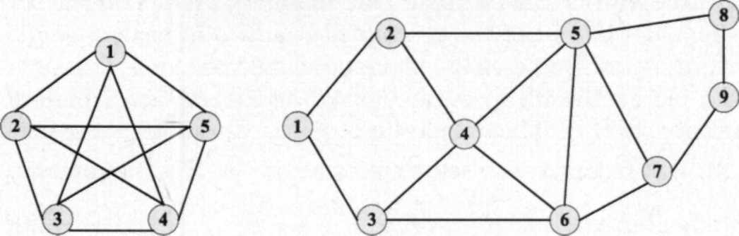
(a) Fully Connected Network (b) Typical ISP Network
Figure 2. Network Topology
We investigated the following three algorithms: the shortest-distance path selection algorithm in [10] (named as shortest-distance path), the bandwidth preemption vector-based path selection algorithm in [14] (named as bandwidth preemption vector-based), and our proposed preemption-aware path selection algorithm (named as preemption-aware). There are two network performance metrics, one is connection blocking rate, i.e. the percentage of rejected connections over all arrivals; the other is preemption ratio, i.e. the probability that during an LSP establishment at least a single lower priority LSP is preempted.
Figure 3 compares the connection blocking rate of three algorithms in terms of average link utilization, (a) is for the fully connected network and (b) is for the typical ISP network. It can be seen from (a) that for all algorithms, the connection blocking rate increases with the average link utilization. It seems that the performance of our preemption-aware approach is similar to that of the bandwidth preemption vector-based approach, and both of them perform better than the shortest-distance path approach, owing to considering the resource reservation information of lower priority LSPs in path selection and reducing preemption and rerouting. The difference of the bandwidth preemption vector-based approach and our approach is due to their characteristics of routing. The bandwidth preemption vector-based approach first limits the candidate
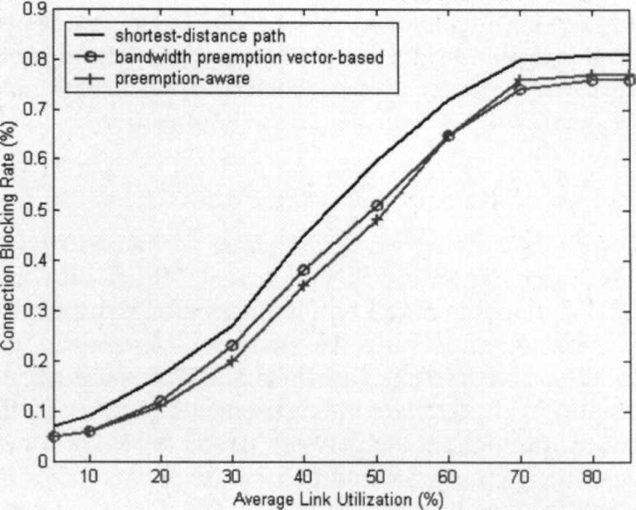
(b) Typical ISP Network Figure 3. Connection Blocking Rate
paths to the shortest ones, and performs better when network load is heavy. While our approach puts more emphasis on load balancing, and pays off when network load is light. From (b) we can draw the similar conclusions.
Figure 4 shows the preemption ratio of three algorithms. We can see from (a) and (b) that when the average link utilization increases, the probability of preemption also increases. The preemption ratio of our approach is obviously less than that of the shortest-distance path approach. The reason is that our algorithm introduces the preemption-related information in the path selection and finds the optimal path with preemption minimization. There is few difference between our approach and the bandwidth preemption vector-based approach, as both of them regard the affected priority level and the bandwidth to be preempted as preemption-related information. It is worth mentioning that the performance gain is more distinct for (a). We can infer that the efficiency of our algorithm will be improved if the topology with more alternative paths is used.
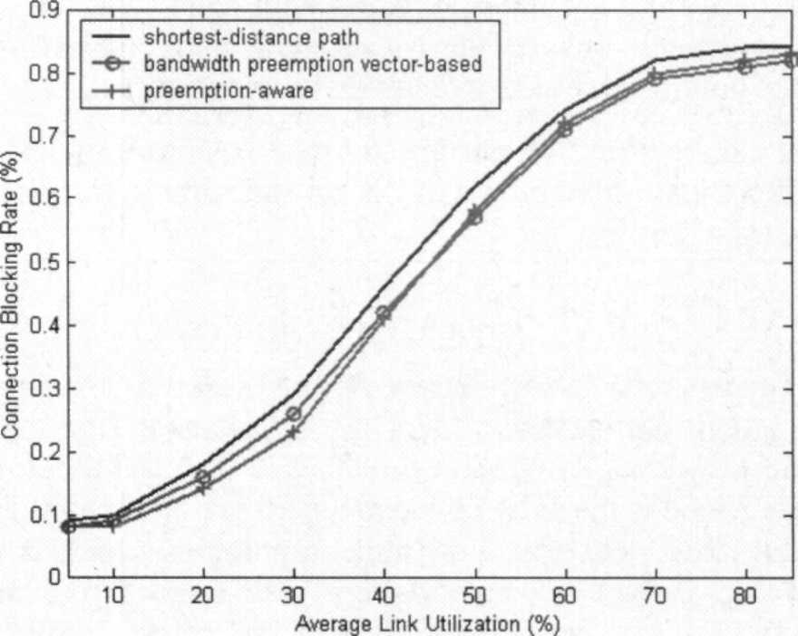
(a) Fully Connected Network (a) Fully Connected Network
5
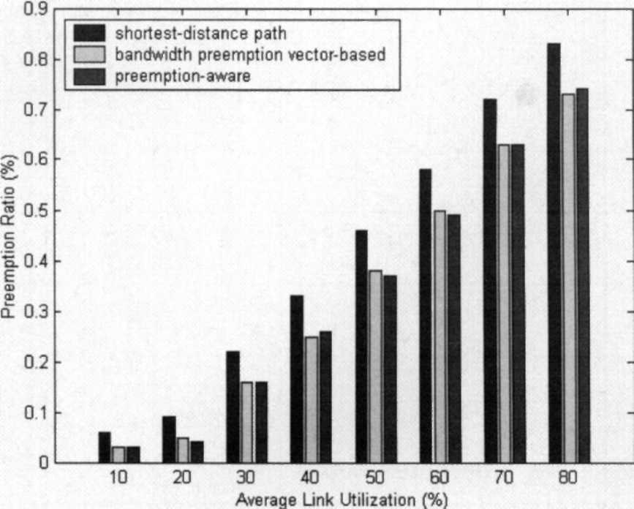
(b) Typical ISP Network Figure 4. Preemption Ratio
In addition, in order to explain the performance difference between our proposed algorithm and the bandwidth preemption vector-based routing algorithm, we examine the max and average link utilization for the two algorithms. The topology is the typical ISP network. We use the total throughput, i.e. the sum of all established LSP's bandwidth, as a measure. Figure 5 shows that for the same throughput, our algorithm leads to less max and average link utilization. Since our algorithm gives priority to load balancing while the bandwidth preemption vector-based algorithm only consider the shortest paths, our algorithm can distribute traffic more evenly throughout the network. Note that the advantage of our algorithm is reduced when network is heavily loaded, as our algorithm will use longer path while the total throughput remains unchanged.
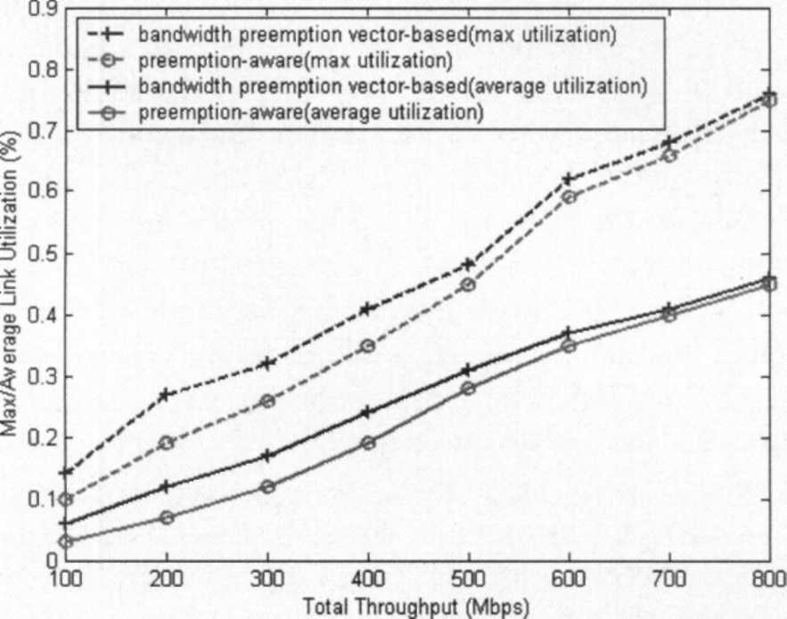
Figure 5. Max/Average Link Utilization vs Total Throughput
V. Conclusions
DS-TE allows the preemption among LSPs with different priority levels. In order to reduce the rerouting and enhance the network stability, we proposed a preemption-aware bandwidth-constrained path selection algorithm, which considers the resource reservation of lower priority LSPs in path selection. By modifying the cost function and introducing preemption-related information (the bandwidth to be preempted and the affected priority level), we can find an optimal path with preemption minimization. Simulations show that our proposed algorithm can achieve preemption and rerouting minimization as well as load balancing, and efficiently improve network performance.
Our algorithm is simple and need not modify existing IGP extension. In order to consider accurate preemption-related information, per-LSP information of each link must to be disseminated. Future works involve studying how to extend IGPs farther in order to integrate preemption and path selection more efficiently.
References
[I] F. Le Faucheur, W. Lai, "Requirements for Support of Differentiated Services-aware MPLS Traffic Engineering", IETF RFC 3564, July 2003.
[2] S. Blake, et al., "An Architecture for Differentiated Services", IETF RFC 2475, Dec. 1998.
[3] D. Awduche, et al, "Requirements for Traffic Engineering Over MPLS", IETF RFC 2702, Sept. 1999.
[4] J. A. Garay, I. S. Gopal, "Call Preemption in Communication Networks", Proceedings of the IEEE INFOCOM'92, vol.3, pp.1043-1050, May 1992.
[5] M. Peyravian, A. D. Kshemkalyani, "Connection Preemption: Issues, Algorithms, and a Simulation Study", Proceedings of the IEEE INFOCOM'97, vol.1, pp.143-151, April 1997.
[6] J. C. de Oliveira, C. Scoglio, I. F. Akyildiz., G. Uhl, "A new preemption policy for DiffServ-aware traffic engineering to minimize rerouting", Proceedings of the IEEE INFOCOM 2002, vol.2, pp.23-27, June 2002.
[7] V. Stanisic, M. Devetsikiotis, "A dynamic study of providing quality of service using preemption policies with random selection", Proceedings of the ICC'03, vol.3, pp.1543-1546, May 2003.
[8] G. Apostolopoulos, et al., "QoS Routing Mechanisms and OSPF Extensions", IETF RFC 2676, August 1999.
[9] Z. Wang and J. Crowcroft, "Quality-of-Service Routing for Supporting Multimedia Applications", IEEE JSAC, 14(7) pp.1288-1234, September 1996.
[10] W. Ma, P. Steenkiste and H. Zhang, "Routing High-Bandwidth Traffic in Max-Min Fair Share Networks", Proceedings of the ACM SIGCOMM, pp.206-217, August 1996.
[II] R. J. Gibbens, F. P. Kelley, and P. B. Key, "Dynamic Alternative Routing - Modeling and Behaviour", Proceedings of the 12^{lh} International Teletraffic Congress, June 1988.
[12] Qingming Ma; Steenkiste, P., "On path selection for traffic with bandwidth guarantees", Proceedings of IEEE International Conference on Network Protocols, pp.191-202, Oct. 1997.
[13] F. Blanchy, L. Melon, G. Leduc, "Routing in a MPLS network featuring preemption mechanisms", Proceedings of the ICT 2003, vol.1, pp.253260, March 2003.
[14] B. Szviatovszky, A. Szentesi, and A. Juttner. "Minimizing re-routing in MPLS networks with preemption-aware constraint-based routing", Computer Communications 25 (1076-1083), 2002.
6
